Electric Shifter
The electric shifter incorporates a Firgelli L12-100-100-12-I linear actuator that mounts to the transmission and moves an arm on the shift shaft:
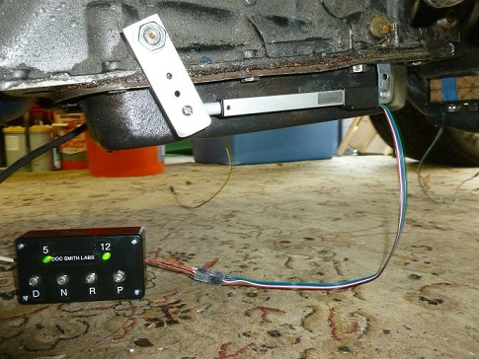
The actuator responds to a control voltage of 0 to 5 volts; 0 is fully retracted and 5 volts is fully extended. A control box generates the voltages via a potentiometer ("pot") for each gear. The pictured box is designed for 4 gears, but more are possible.
To calibrate: mount the actuator to the transmission and attach a suitable arm to the shift shaft, but do not yet attach the actuator to the arm. Then manually place the transmission in a gear and adjust the corresponding pot to extend the actuator so it's pivot coincides with the arm hole. Repeat this for each gear. Then the actuator can be bolted to the arm.
Note that the control voltage must be maintained. If control voltage is removed the actuator will move to the fully retracted position. However if power to the actuator is removed it will remain in the current position.
There is also a gear selector switch. The pictured unit incorporates turn signal controls. The selector could of course be incorporated into an existing dash or console.
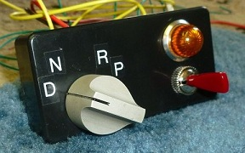

The wiring is straightforward. A 7805 regulator provides 5 volts to the 4 pots. The selector switch feeds the output of the selected pot to the actuator, which shifts the transmission to the corresponding gear. The actuator itself runs on 12 volts. Pot values are not critical. 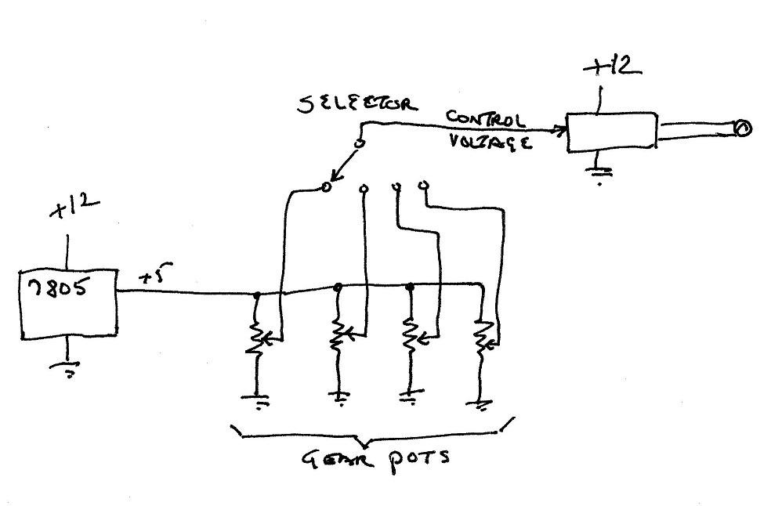
I have a new shifter in the works with a more powerful actuator that will shift faster. The L16-100-35-12-P actuator works with an outboard controller board with speed and sensitivity adjustments.
There are many possible variations on the design. Instead of a rotary selector, push buttons could be used. The circuitry could power the actuator only during shifting, minimizing the chance of an unintended shift caused by an electrical problem. A starter lockout could be incorporated to prevent starting while in gear. Or a separate gear position indicator such as the Dakota Digital GSS-2000 could verify gear position and provide starter lockout and backup light functions.

